TECHNO MAIN SALT LAKE
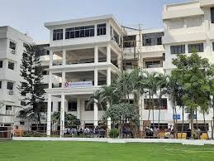

Techno Main Salt-lake is one of the premier institutes, not only in West Bengal but the entire nation. The admission procedure in this college is possible through cracking the most competitive examinations held by the state and central government. Each course has been accredited by licit government bodies. It is affiliated to MAKAUT. To accommodate the needs of the meritorious students, we have highly qualified faculty members teaching here. The academic ambiance is truly unparalleled, and it has been built through hard work and credibility for over 20 years. Being a technical institute, the emphasis is laid on practical learning along with theory-based classes. A number of interesting projects are commenced under doctorate faculty. the students are highly focused on their academics and prospects. Many of the students go on to do their higher studies in institutes such as IIT or IIM. Some appear for GRE and GMAT and go abroad. Many of them also crack government exams and join the public sector while others are placed in good positions at MNCs. The college is situated in a prime location amidst the IT hub of Kolkata. Techno Main Salt-lake is truly the place to pursue academia of the highest value.

END.

